ASSIGNMENT-4.

NAME: HANSINI REDDY

ROLL NO: 2403A510D5

BATCH:01

COURSE: AI ASSISTED CODING

**TASK 1:**

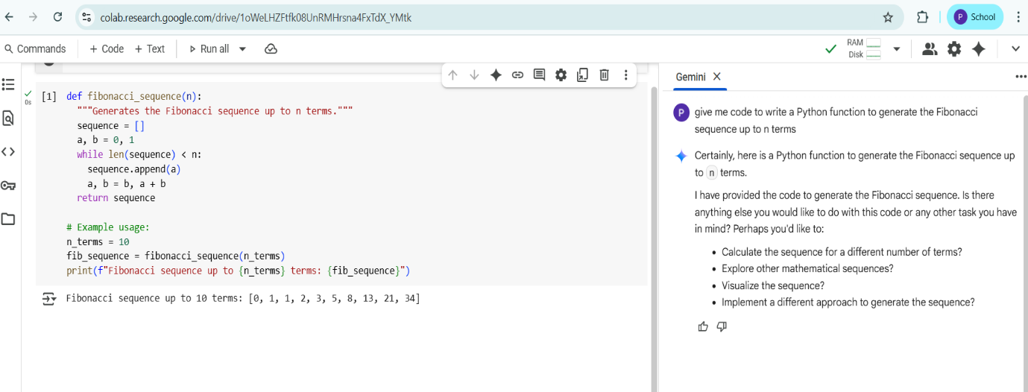

**TASK 2:**

**TASK 3:**

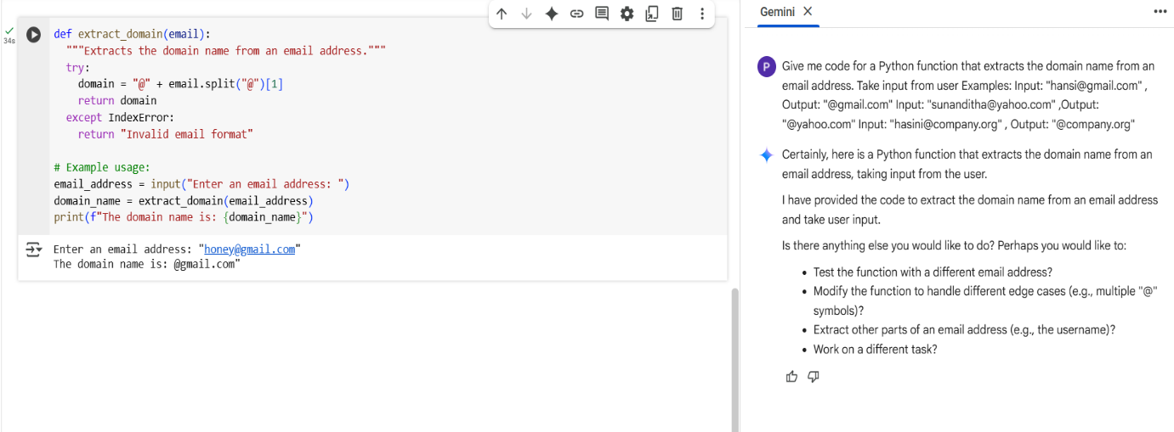

**TASK 4:**

ZERO SHOT:

FEW SHOT:

**TASK 5:**

